February 10, 2022

RE: Approved Stormwater Technologies

RIDOT is aware that RIDEM and CRMC have a listing of approved technologies for stormwater treatment. A designer for a RIDOT project should not presume that the same technologies are approved for RIDOT projects. The Division of Maintenance has approved subset of the RIDEM/CRMC that they have agreed to maintain. This list will be updated as new technologies are approved by RIDEM/CRMC.

The following stormwater technologies are RIDOT approved:

Filterra High Performance Bioretention
Stormceptor Hydrodynamic Separator
Jellyfish Filter
HydroStorm Hydrodynamic Separator

The following technology is NOT approved at this time:
Kraken Filter

Best,

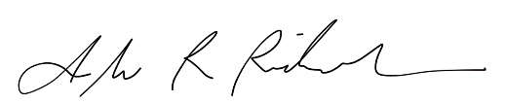

Alisa Diaz Richardson, MS, PE, PMP
Acting Administrator
Environmental Division, RIDOT
401-479-1327

